Refrigerator Curriculum for Pre-Kindergarten
These are some activities to do with your child to help them reach the Pre-K goals.
Reading/Literacy: These activities will help your child increase pre-reading skills.
- Have meaningful 2 way conversations with your child.
- Give your child the freedom of trial and error when working through problems.
- Read to your child at least 10 minutes daily and ask questions of your child about what you read. See if they can predict what comes next.
- Play word games while in the car. Such as: Say “Mat, cat. What else rhymes?”
- Use magnetic letters to help recognize, copy, and write first name.
- Help your child identify capital and lowercase letters. Start with the letters in their name. You can also use the letters in the world around you, for example while at the grocery store.
- Say the name of everyday items out loud to your child such as household items, clothing, and body parts.

Math: These activities will help increase your child pre-math skills.
- Ask your child to “sort” items into piles, such as the white socks and the blue socks.
- Ask your child to find and draw the shapes they see in household items. Example: A TV is a rectangle.
- Use objects and/or sounds to create AB pattern. (spoon, fork, spoon, fork, etc…)
- Try having your child put 8 juices in the refrigerator, or ask “how many?” of something.
- Identify numbers 0-10 out of order. Look at the numbers in the world around you such as your address.
- Encourage your child to write or copy numbers.
- Use the ordering language of “first, second, third, etc…” to describe any routine, such as bedtime.
- Complete 12 piece puzzles.
- Discuss colors around your house; correct your child when they make a mistake.
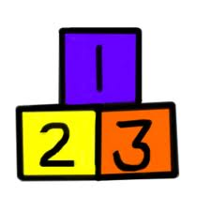
- When giving directions use words like “behind, above, below, under, over, in, up, top, together, apart, on, off, etc...”
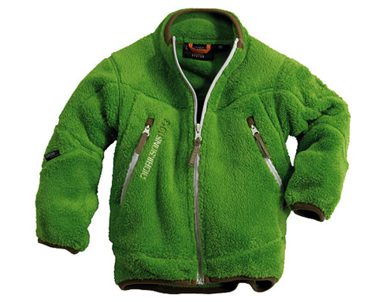
Physical Development, Health, and Safety
- Children need to practice buttoning, zipping, tying shoes, opening water bottles, putting their coat on, and going to the restroom by themselves.
- Practice coloring, cutting, and tracing.
- Take your child to the park and show them how to skip, jump, gallop, hop, stand on one foot, and catch a ball using two hands.
Social Emotional
- Help your child develop self-control by expressing appropriate gestures, actions, and words when frustrated.
- Your child should be able to verbalize their wants and needs. Ask your child to “Use your words.”
- Help child gain an awareness of other’s needs by asking how they would feel if they were in the other person’s place.

Resources to look for at dollar stores or garage sales that will better prepare your child for school.
Websites you can use at home with your child:
- www.starfall.com
- www.scholastics.com
- www.pbskids.org
- www.wegivebooks.org
- www.kidzone.com
- www.atoz.com

Whiteboards with Dry Erase Markers
Board Books
Scissors
Play dough
Sidewalk Chalk
Letter and Number Magnets
Dice
Dominoes
Playing Cards
Crayons/Markers
Glue
Pencils/Pens
Puzzles

Hazelwood School District Refrigerator Curriculum for Title 1 Pre-Kindergarten
Created by Title 1 Pre-K Teachers for Pre-K Parents
2012-2013

